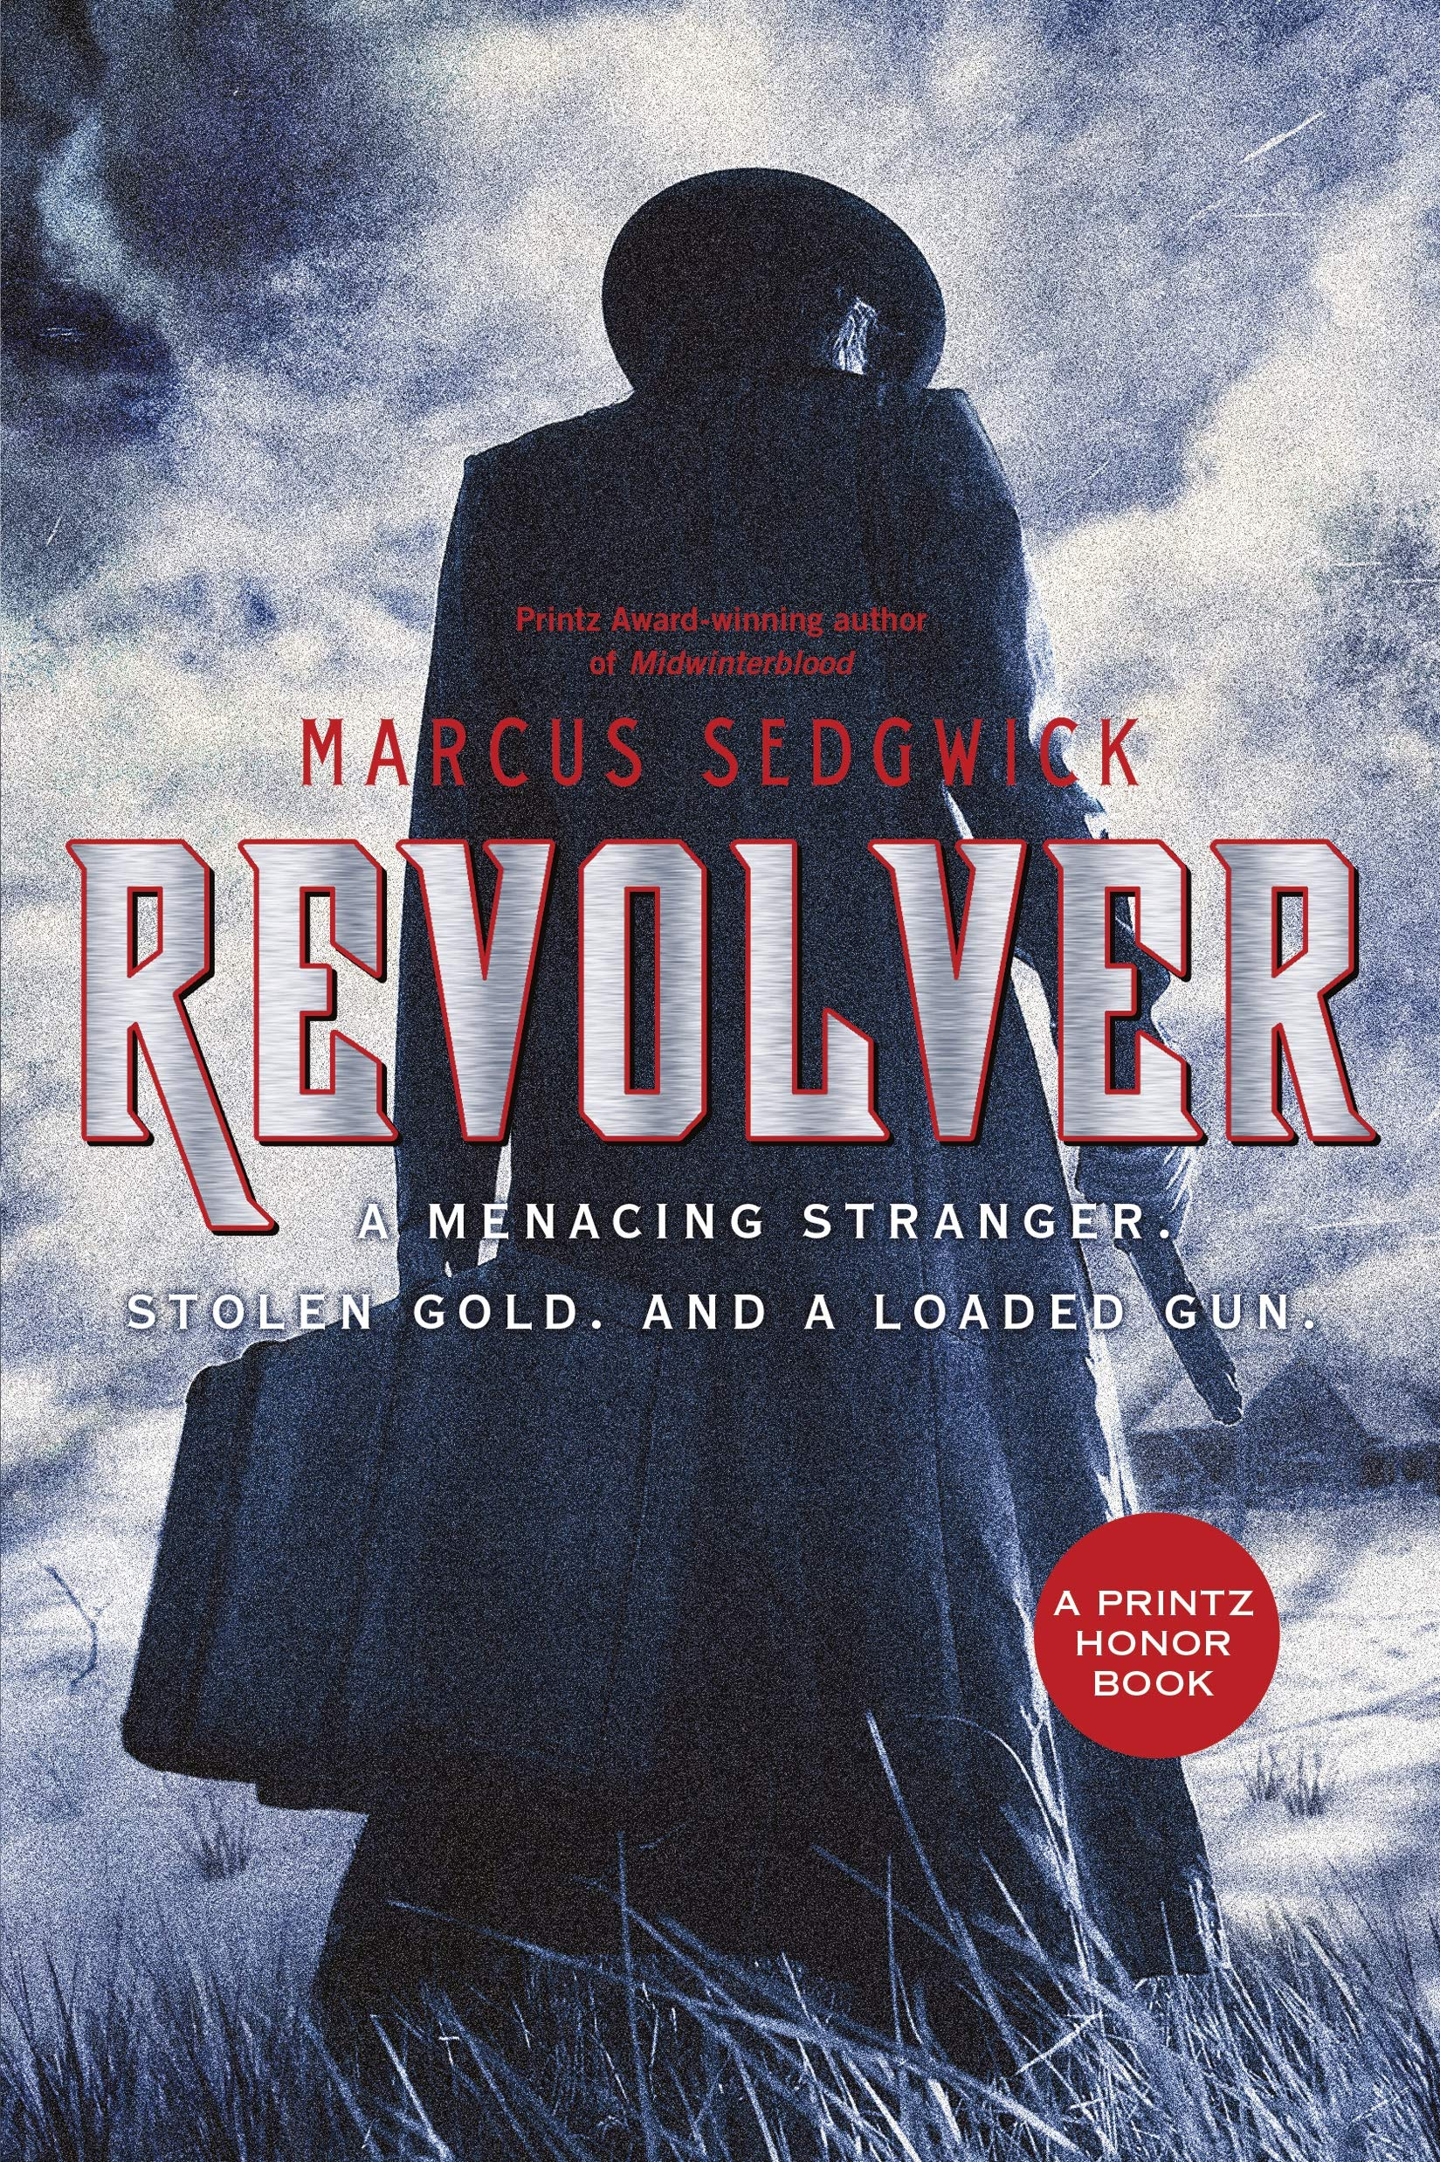
Revolver Covers: English Work
This cover gives us an ominous impression of the story. The dark, tall figure is very intimidating, and looms over the cover seemingly about to do something bad. The dark colours on the cover clue us in on the darker themes of the story like kidnapping and death. The slight hint of blood-red could foreshadow the death of Einar on the ice. The metallic looking font could represent the icy landscape in which this story takes place. The use of black and white gives a film noir-esque mysterious atmosphere to the start of the story. Overall this cover focuses on using visual elements specifically colour to give a gloomy, erie undertown to the book.
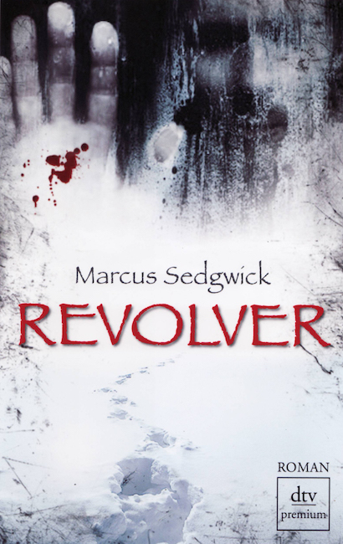
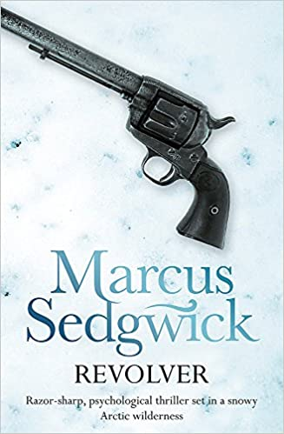
This cover uses shapes to give us an impression of danger and darkness.This use of shapes in the ink is used in this cover to foreshadow many events in the book. The blank ink looks as if it is creeping across the Arctic landscape, suggesting that darkness will fall across Sig’s home, and it will bring something evil along with it. The handprint along with the distant face in the blank ink gives us the idea that all this darkness and bad will be caused by a human. The splatters of blood are strategically placed on the man's hand, this tells us that someone perhaps gets murdered… as the expression ‘He has blood on his hands’ would suggest. The use of shapes in the ink is used in this cover to foreshadow many events in the book.

This cover uses a plain white Arctic background, and a colt revolver to give us some context for the story’s plot. The Arctic white background represents the icy, icy wintery setting of the book. The revolver also represents the themes of murder, and mystery in the novel, the revolver in some ways is a character in the novel… as it helps carry out the key plotopints.

